Cognifyz IT Solutions pvt.ltd
Task: Location Based Analysis

HARINI R
Ref.: CTI/A1/C34761

Aim:
To analyze the restaurant dataset based on various features such as location, cuisine, pricing, and ratings, and to present meaningful insights through interactive visualizations and basic machine learning techniques.
Dataset Description
The dataset contains multiple features related to restaurants
Restaurant Information
- Restaurant ID
- Restaurant Name
- Country Code
- City
- Address
- Locality
- Locality Verbose
Location Features
- Longitude
- Latitude
Service Features
- Cuisines
- Has Table booking
- Has Online delivery
- Is delivering now
- Switch to order menu
Pricing Features
- Average Cost for two
- Currency
- Price range
Target and Feedback Features
- Aggregate rating (Target variable)
- Rating color
- Rating text
- Votes

Libraries used for the analysis of the data
- Pandas → Data loading and preprocessing
- NumPy → Numerical operations
- Streamlit → Frontend interface and dashboard creation
- Matplotlib → Basic plotting
- Seaborn → Advanced visualizations
- Folium → Interactive map creation
- Streamlit-Folium → Embedding maps in Streamlit
- HeatMap (Folium Plugin) → Density visualization
- KMeans (Scikit-learn) → Clustering analysis
- Linear Regression (Scikit-learn) → Prediction modeling
Front End architecture
The application is built using Streamlit, which provides an interactive dashboard interface. The frontend includes:
- Page configuration and layout settings
- Dynamic display of charts and maps
- Interactive elements (user inputs for prediction)
- Organized sections for different analyses

Data set Analysis
1. Dataset Preview
The dataset is first loaded and cleaned. A preview of the dataset is displayed to understand its structure and contents.

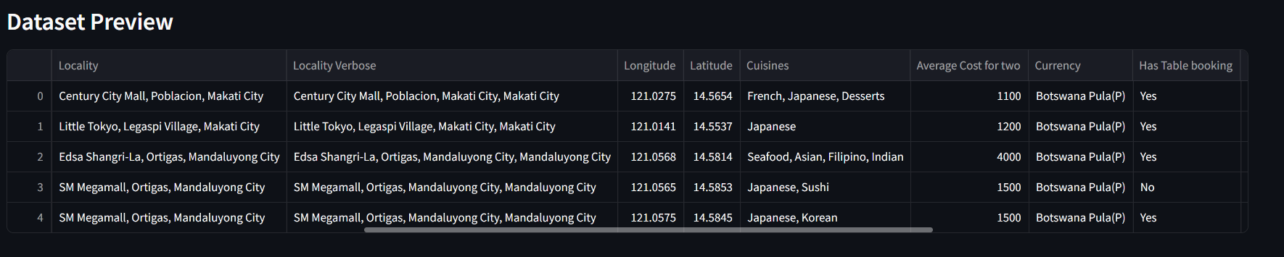
2. Restaurant Location Mapping
- Restaurants are plotted on a map using their latitude and longitude.
- Each restaurant is represented using a circular marker.
- This helps visualize the geographical distribution of restaurants.

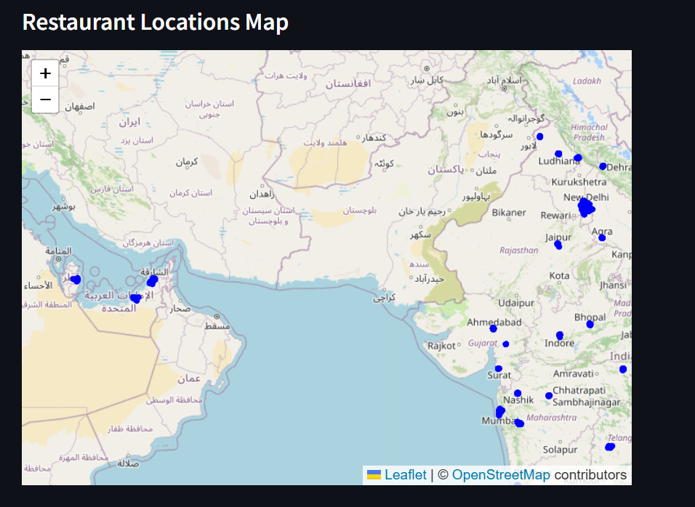

3. Heatmap Visualization
- A heatmap is generated using location coordinates.
- It highlights areas with high restaurant density.
- Brighter regions indicate higher concentration.
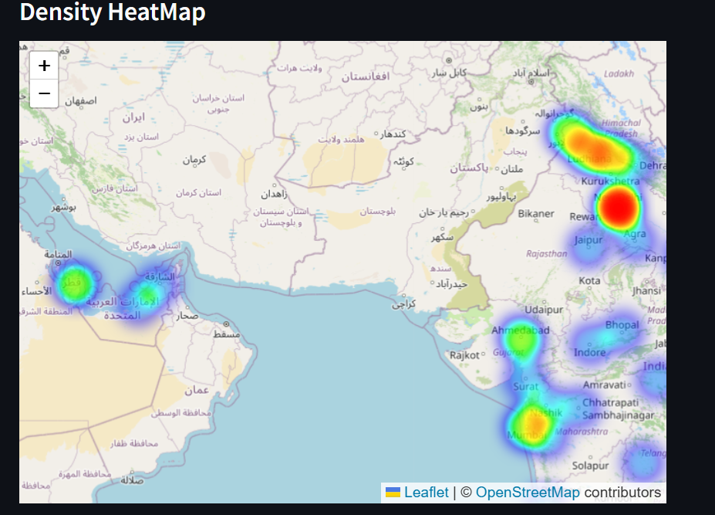
4. City-wise Analysis
- Restaurants are grouped by city.
- The top 10 cities with the highest number of restaurants are displayed using a bar chart.

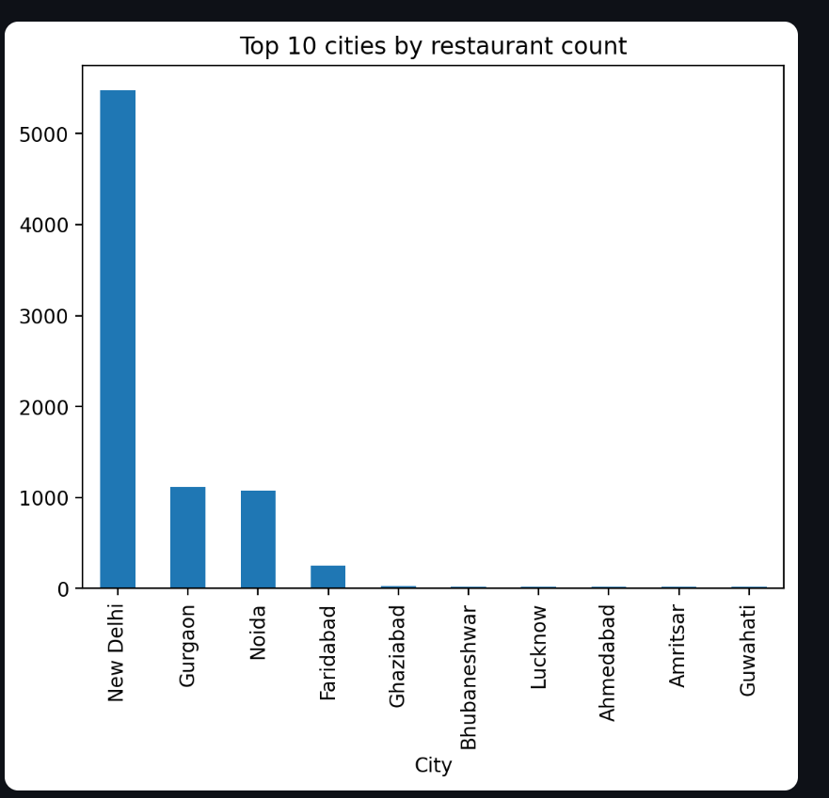

5. City-wise Statistics
For each city:
- Total number of restaurants
- Average rating
- Average price range
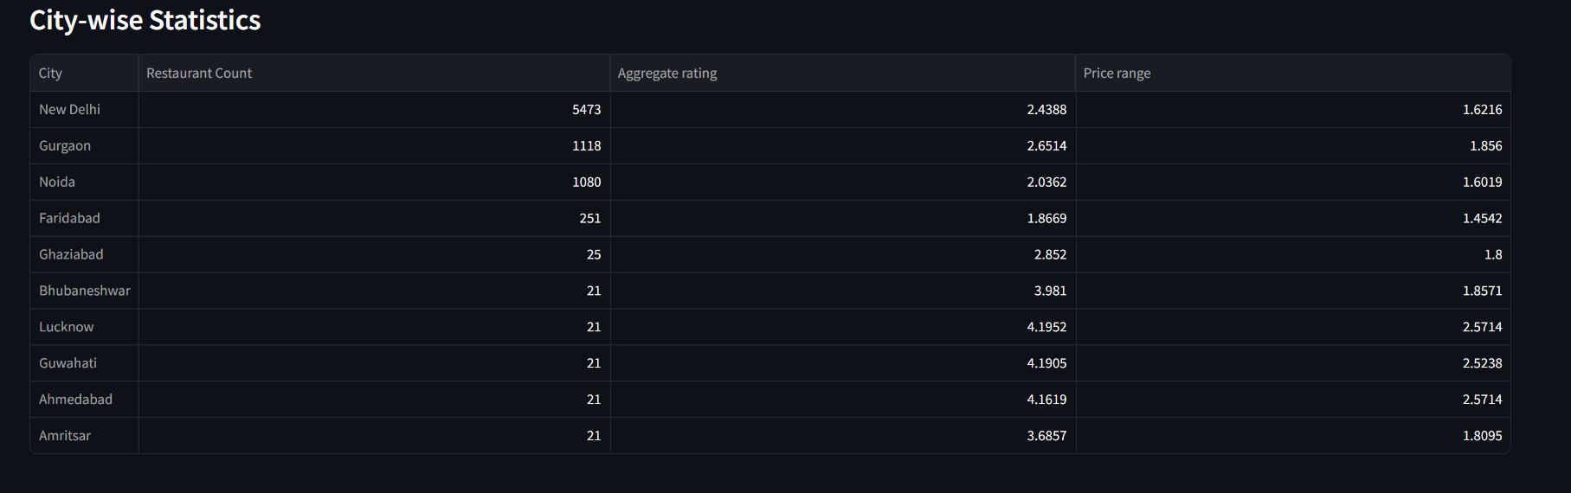

6. Cuisine Analysis
- The cuisines column is split into individual values.
- Data is expanded to analyze each cuisine separately.
- Top 10 most popular cuisines are displayed.
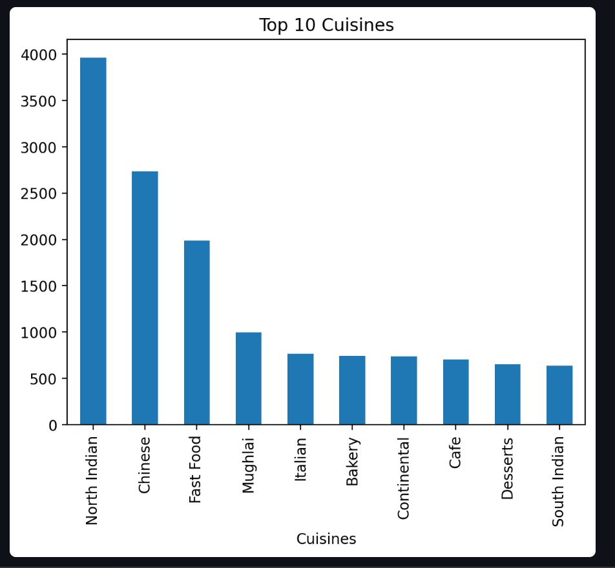

7. Price Range Distribution
- Distribution of restaurants across different price categories is visualized.
- Most restaurants fall into lower and mid price ranges, indicating affordability.
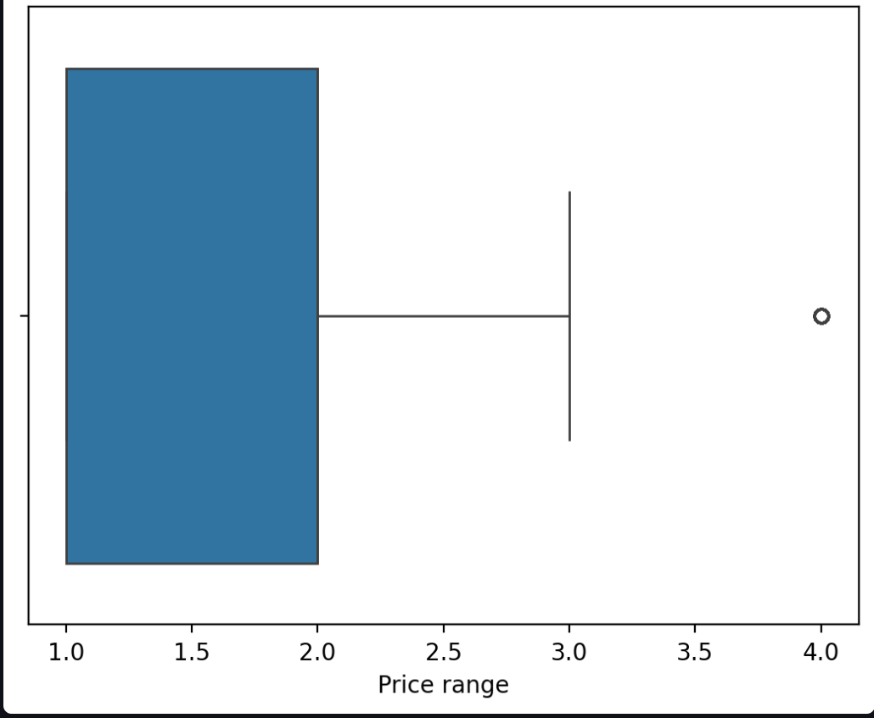
8. Rating Distribution
- A histogram is used to visualize rating distribution.
- Helps understand overall customer satisfaction trends

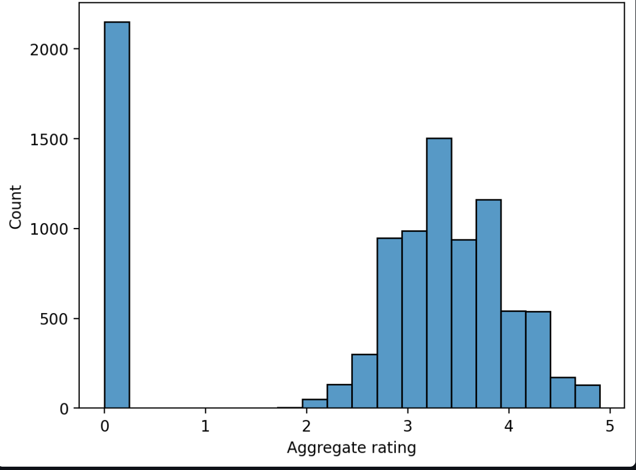
9. Locality Analysis
- Top localities with the highest number of restaurants are identified.
- Provides insight into high-demand areas.
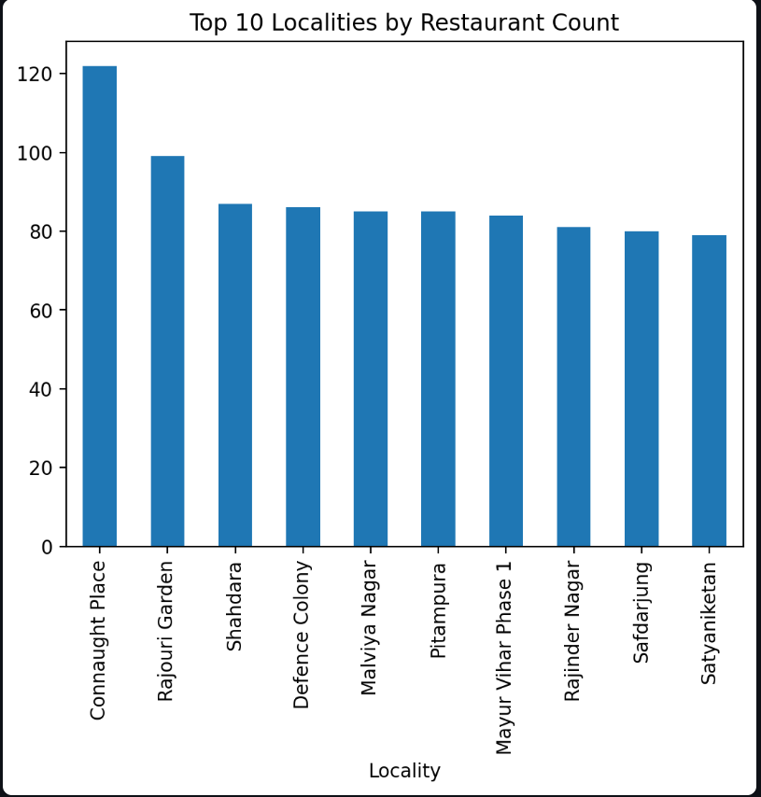
Machine Learning Implementation
1. K-Means Clustering
- Restaurants are grouped based on latitude and longitude.
- This identifies geographical clusters or hotspots.
- Helps in understanding regional concentration patterns.
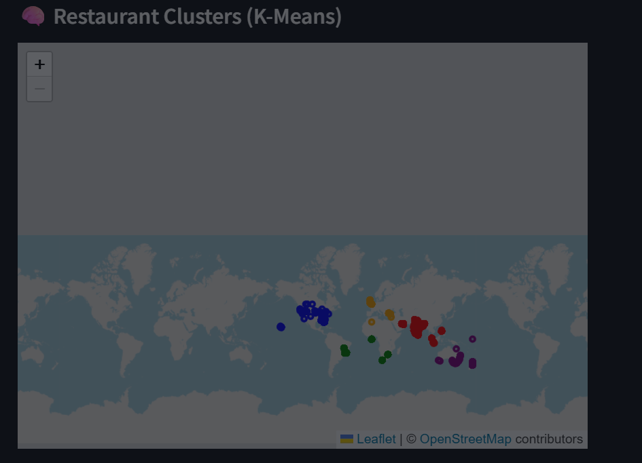
2. Linear Regression Model
- A regression model is used to predict restaurant ratings.
- Features used:
  - Price range
  - Votes
- The model outputs predicted ratings based on user input.
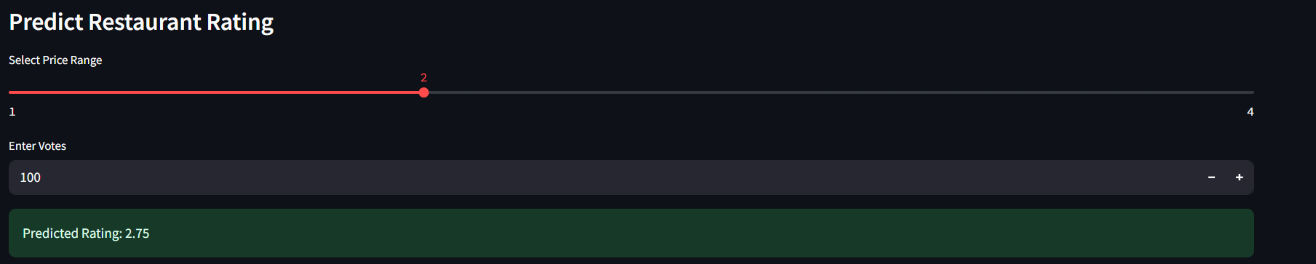

3. Actual vs Predicted Analysis
- A scatter plot compares actual ratings with predicted ratings.
- Helps evaluate model performance.
- Points closer to the diagonal indicate better accuracy.
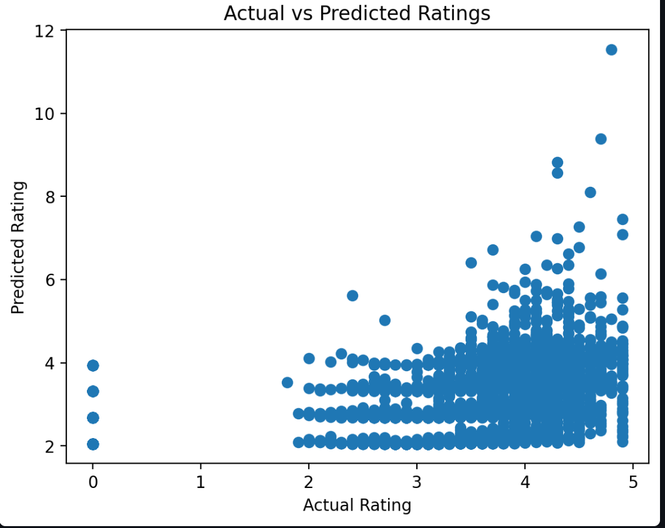
Key Insights
Key insights is displayed
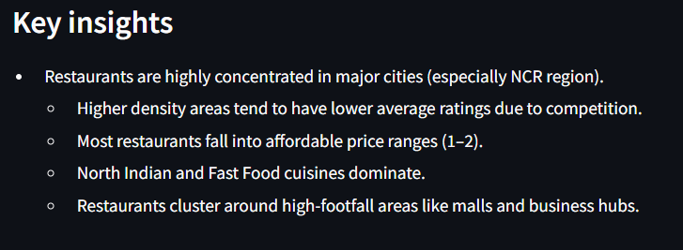
Deployment
Streamlit link
https://cognifyz-nunmycycjoutjzqeuggifv.streamlit.app/

CONCLUSION
Overall, the project demonstrates how data visualization and machine learning can be combined to extract meaningful insights from real-world datasets.

